NABAVA MEDICINSKE OPREME ZA DOM ZDRAVLJA VIROVITIČKO-PODRAVSKE ŽUPANIJE

Putem programa donacija, Vlada Japana odobrila je iznos od 57,145 Eura Domu zdravlja Virovitičko-podravske županije za nabavu medicinske opreme za potrebe ambulante u Voćinu.

Ratom oštećena ambulanta Voćin, obnovljena je u 2006. godini. Djeluje u okviru Doma zdravlja Virovitičko-podravske županije u Virovitici, gradu udaljenom 35 km od naselja Voćin. Ovo područje pretrpjelo je znatne štete usljed ratnih zbivanja tijekom 90-ih.
Ambulanta Voćin pruža medicinske usluge stanovnicima općine Voćin koja broji oko 2.500 ljudi. U nastojanjima da podupre aktivnosti ove ambulante, Vlada Japana je omogućila nabavu novog ambulantnog vozila, vrijednosti 48,849 eura u ožujku 2004. godine. Ovog puta sredstva su utrošena za nabavu osnovne medicinske opreme i namještaja.

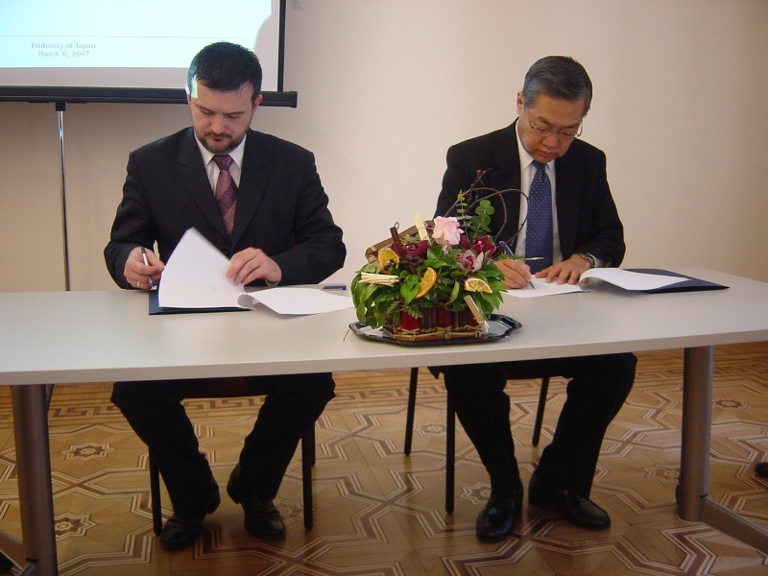 | 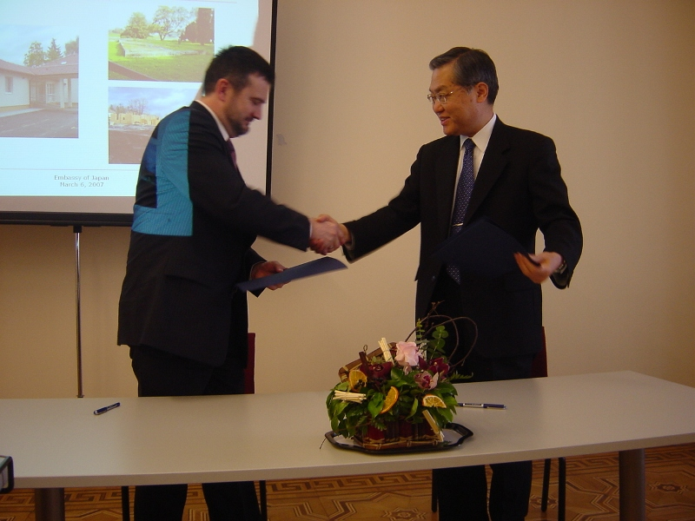
Darovni ugovor potpisali su veleposlanik Shirakawa i ravnatelj Doma zdravlja Virovitičko-podravske županije, g. Tomislav Boban

Provision of Medical Equipment for the Virovitica-Podravina County Health Centre

The Government of Japan under the Japan's Grassroots Grant Assistance Scheme has provided a total grant of 57,145 EUR to the Virovitica-Podravina County Health Centre to cover the medical equipment provision costs for the infirmary in Voćin.

Voćin infirmary, badly destroyed during the war, was reconstructed in 2006. It is under the authority of Virovitica-Podravina County Health Centre which is located in Virovitica town, 53 km from Voćin. The area had suffered considerable damage as a result of the conflict in the 1990s.
Infirmary Voćin is providing medical services to people of Voćin municipality, population of around 2.500 people. In order to support activities of this infirmary, the Government of Japan has already made a provision of equipped ambulance vehicle, grant aid of 48,849 EUR in March 2004. The items provided this time are basic medical instruments and furniture.

